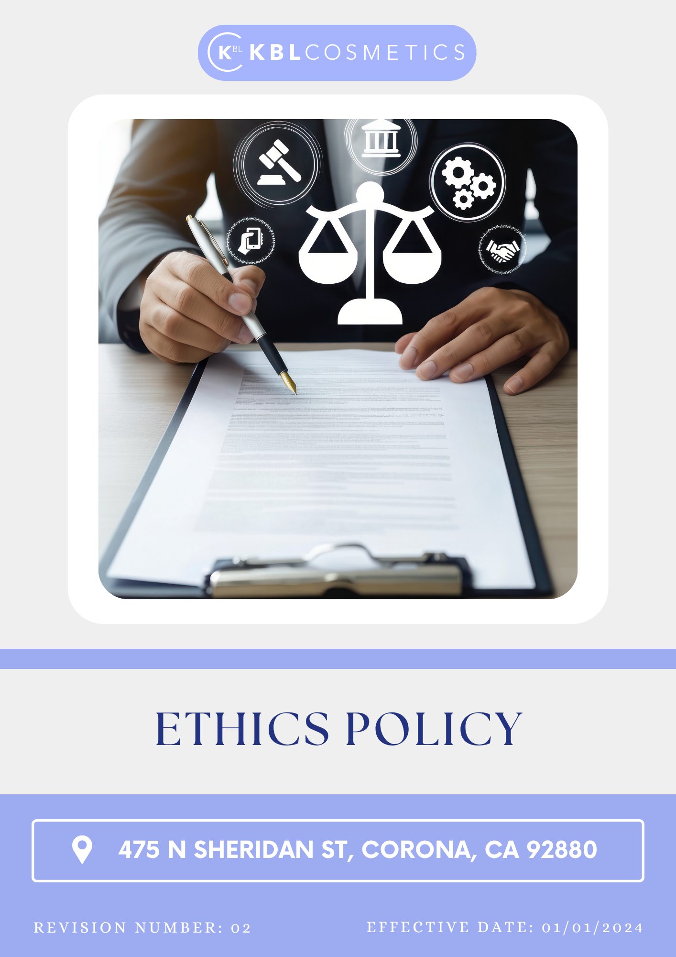

Table Of Contents

1. Introduction 3
2. The Arminak Solutions LLC dba KBL Cosmetics Approach 3
3. Scope 3
4. What's Expected 3
5. Journey to Responsibility: An Arminak Solutions LLC dba KBL Cosmetics Commitment 4
6. Ethical Guidelines 6
7. Do’s & Don’ts 6
8. Actions Regarding Violation of the Policy 7
9. Responsibility 8
10. Reporting Section 9
11. Covered SDGs 10
12. Review Mechanism 10
13. Employee Acknowledgement Form: Ethics Policy 11

Introduction
Arminak Solutions LLC dba KBL Cosmetics is committed to conducting business with integrity, transparency, and accountability. As a company operating in the cosmetics industry, we recognize our responsibility to uphold the highest ethical standards in all aspects of our operations. Ethical behaviour is fundamental to building trust with our customers, employees, suppliers, and stakeholders. This Ethics Policy serves as a guiding framework for ethical decision-making within our organization. It defines our commitments to compliance, fair business practices, human rights, environmental responsibility, data privacy, and whistleblower protection.

The Arminak Solutions LLC dba KBL Cosmetics Approach
At Arminak Solutions LLC dba KBL Cosmetics, we integrate ethical considerations into our daily operations and decision-making processes. Our approach is rooted in embedding ethical values into corporate culture is essential and can be achieved through effective leadership and employee engagement. Regular risk assessments should be conducted to identify and mitigate potential ethical issues. Additionally, providing training programs enhances awareness and understanding of ethical standards. It is crucial to establish clear policies and procedures that guide ethical behavior across all business functions. Collaborating with industry partners, NGOs, and regulatory bodies helps organizations stay aligned with global ethical standards.

We set annually goals, develop necessary capabilities, and commit appropriate resources to achieve this policy through innovation, operational efficiency, and aligning Arminak Solutions LLC dba KBL Cosmetics supply chain with this policy.

Scope
This policy applies to all employees, stakeholders, contractors, partners, customers, contractual workers, and anyone acting on behalf of following sites:

   | ARMINAK SOLUTIONS LLC DBA KBL COSMETICS
 | Address: 475 N Sheridan St, Corona, CA 92880
 | https://kblcosmetics.com/

What's Expected

- Compliance with Laws and Regulations
All relevant national and international laws and regulations are closely adhered to by Arminak Solutions LLC dba KBL Cosmetics. We guarantee compliance with labor laws, environmental rules, anti-corruption laws, and ethical business practices.
Arminak Solutions LLC dba KBL Cosmetics has established key commitment to ethical business practices:
Ensuring Ethical Supply Chains: We continuously engage with our suppliers to ensure fair labor practices, responsible sourcing, and ethical procurement.
Promoting Diversity and Inclusion: We foster a workplace that values diversity, promotes equal opportunities, and supports a culture of inclusivity.
Maintaining Zero Tolerance for Corruption: We uphold strict anti-corruption policies and ensure that all business dealings are conducted with honesty and transparency.
Enhancing Employee Training: We provide regular training on ethical standards, compliance, and corporate responsibility to all employees and stakeholders.
Advancing Sustainability Practices: We integrate sustainable solutions in product development, manufacturing, and distribution to minimize environmental impact. Strengthening Data Protection: We uphold the highest standards of data privacy and security to protect the personal and business information of our employees, customers, and partners.
Strengthening Information Security and Data Protection: We uphold the highest standards of information security, cybersecurity, data privacy, and confidentiality to protect the personal and business information of our employees, customers, suppliers, and partners. We implement appropriate technical, administrative, and organizational controls to prevent unauthorized access, data breaches, cyber threats, and misuse of sensitive information.
Managing Conflict of Interest: We are committed to identifying, disclosing, and appropriately managing actual, potential, or perceived conflicts of interest to ensure that business decisions are made objectively, ethically, and in the best interest of the company. Employees, management, and stakeholders are expected to avoid situations where personal, financial, or external interests could improperly influence professional judgement, decision-making, or business relationships.
Supporting Community Development: We actively engage in corporate social responsibility initiatives, supporting local communities and charitable organizations.
Improving Workplace Well-being: We prioritize employee well-being by fostering a positive work environment, providing mental health support, and ensuring a healthy work-life balance.
Increasing Transparency in Reporting: We maintain open and honest communication with stakeholders by providing regular reports on ethical compliance and sustainability efforts. Encouraging Ethical Innovation: We promote the development of ethical and sustainable products, leveraging research and innovation to minimize environmental and social impact.

Journey to Responsibility: An Arminak Solutions LLC dba KBL Cosmetics Commitment
Establishes 2022 as the Baseline year for measuring progress and achievements in our sustainability initiatives.

- Corruption:
- We aim to conduct comprehensive anti-corruption risk assessments covering 100% of business functions annually by 2030.
- We ensure that 100% completion rate for annual anti-corruption training among all employees by 2030.
- We ensure that 100% of new third-party partners undergo thorough anti-corruption due diligence before engagement by 2030.
- We are committed to maintaining a strict policy of zero tolerance towards any form of corruption. This unwavering stance reflects our dedication to integrity and ethical conduct in all our operations.

- Conflict of interest:
- We aim to ensure that 100% of employees complete a conflict-of-interest disclosure form annually.
- We plan to achieve a 100% completion rate for conflict-of-interest training among all employees by 2030.
- We intend to address and resolve 90% of reported conflict of interest incidents within 30 days of disclosure by 2030.
- We plan to integrate conflict-of-interest compliance requirements into supplier, contractor, and third-party engagement processes by 2030.
- We aim to ensure that all employees disclose any external employment, financial interests, or business relationships that may create actual, potential, or perceived conflicts of interest by 2030.

- Fraud:
- We aim to conduct comprehensive fraud risk assessments covering all business functions annually, starting in 2030.
- We plan to achieve a 100% completion rate for annual fraud awareness training among all employees by 2030.
- We intend to deploy advanced fraud detection and prevention technologies across all critical business processes by 2030.
- We ensure that 100% of new suppliers and business partners undergo thorough fraud risk assessments before engagement by 2030.

- Money laundering:
- We aim to ensure that conduct comprehensive Anti-Money Laundering (AML) risk assessments covering all business functions annually, by 2030.
- We plan to achieve a 100% completion rate for annual Anti-Money Laundering (AML) training among all employees by 2030.
- We intend to ensure that 100% of new third-party partners undergo thorough Anti-Money Laundering (AML) due diligence before engagement by 2030.
- Information security:
- We aim to ensure 100% of employees complete annual information security training by 2030.
- We aim for a decrease in phishing simulation click rates to below 5% by 2030.
- We intend to conduct monthly vulnerability scans and remediate 90% of identified high-risk vulnerabilities within 15 days by 2030.
- We plan to implement Multi Factor Authentication (MFA) for 100% of employees accessing sensitive systems by 2030.
- We intend to ensure that 100% of critical business systems are protected with updated antivirus, firewall, and endpoint security solutions by 2030.
- We aim to implement data loss protection solutions to monitor and protect 100% of sensitive data transmissions by 2030.
- We aim to achieve 100% secure backup coverage for critical business data and systems by 2030 to support business continuity and disaster recovery.
- We aim to implement role-based access controls for all critical systems and sensitive information assets by 2030.
- We intend to conduct periodic reviews and updates of information security procedures to align with evolving cyber threats, regulatory requirements, and industry best practices by 2030.

- Ethical Supplier Certification:
- We aim that 100% of suppliers are certified under recognized ethical standards, such as Fair Trade or equivalent, by 2030.
- We plan to collaborate with ethically certified suppliers strengthens the integrity of the supply chain by 2030.

Ethical Guidelines
Arminak Solutions LLC dba KBL Cosmetics has established the following ethical guidelines to ensure compliance with our Ethics Policy. These guidelines apply to all employees, business partners, and stakeholders.
- Integrity and Honesty
- Employees must be honest in all business dealings and avoid deceptive practices.
- Fair Competition
- Employees must compete fairly and not engage in anti-competitive practices such as price-fixing or market manipulation.
- Conflicts of Interest
- Employees must disclose any personal or financial interest that could influence their business decisions.
- Workplace Respect and Inclusion
- Discrimination, harassment, and workplace bullying are strictly prohibited.
- Anti-Bribery and Corruption
- Employees must not offer, accept, or solicit bribes, kickbacks, or any improper payments.
- Ethical Sourcing and Environmental Responsibility
- Suppliers must follow sustainable and ethical labor practices, ensuring fair wages and safe working conditions.
- Confidentiality and Data Protection
- Employees must safeguard customer, employee, and company data from unauthorized access or disclosure.
- Whistleblower Protection
- Employees who report ethical violations in good faith will be protected from retaliation.

Do’s & Don’ts
To ensure ethical governance is upheld at all levels, the following guidelines outline the appropriate and inappropriate actions for employees, managers, directors, and external stakeholders.

Anti-Corruption and Fraud Prevention
✅ Do’s
- Report any suspicious activities or bribery attempts to the Compliance Officer.
- Maintain clear and transparent records of all financial transactions.
- Adhere to all anti-corruption policies and training requirements.
- Refuse gifts or incentives from suppliers that may influence business decisions.
❌ Don’ts
- Do not offer or accept bribes in any form.
- Do not falsify or manipulate financial records.
- Do not engage in fraudulent business dealings or misrepresent facts.
- Do not ignore or withhold information regarding corruption risks.

Conflict of Interest Management
✅ Do’s
- Disclose any personal or financial relationships that could create a conflict of interest.
- Seek approval before engaging in any external business relationships related to Ami Lifesciences.
- Follow company procedures for reporting conflicts of interest.
❌ Don’ts
- Do not make decisions that personally benefit you at the expense of the company.
- Do not engage in business with direct competitors without approval.
- Do not misuse company resources for personal gain.

Money Laundering Prevention
✅ Do’s
- Report any suspicious transactions to the compliance department.
- Conduct due diligence before engaging with new business partners.
- Maintain accurate financial records and transaction logs.
❌ Don’ts
- Do not process or approve transactions that lack clear business justification.
- Do not ignore red flags related to suspicious financial activities.
- Do not engage in structuring transactions to evade reporting requirements.

Anti-Competitive Practice Avoidance
✅ Do’s
- Compete fairly and ethically in the marketplace.
- Follow all applicable competition laws and regulations.
- Ensure transparency in negotiations and pricing strategies.
❌ Don’ts
- Do not engage in price-fixing, bid-rigging, or market allocation schemes.
- Do not discuss competitive pricing strategies with competitors.
- Do not misuse market influence to eliminate competition unfairly.

Information Security and Data Protection
✅ Do’s
- Follow company cybersecurity policies to protect sensitive data.
- Use strong passwords and enable multi-factor authentication where required.
- Report any suspicious emails, phishing attempts, or data breaches immediately.
❌ Don’ts
- Do not share confidential company data with unauthorized individuals.
- Do not use personal devices to store or transmit company-sensitive information.
- Do not click on unknown or suspicious links in emails or messages.

Actions Regarding Violation of the Policy
Arminak Solutions LLC dba KBL Cosmetics takes violations of this Ethics Policy very seriously and has established a structured process to handle them effectively. The following actions will be taken in cases of violations, enforces a strict approach to handling violations of this Ethics Policy. Actions taken against violations include:
- Investigation and Review: All reported violations will be thoroughly investigated by the Compliance Manager and relevant authorities within the company.
- Corrective Actions: Depending on the severity of the violation, corrective actions will be implemented, including policy reinforcement, additional training, or procedural adjustments.
- Disciplinary Measures: Employees or stakeholders found guilty of ethical misconduct may face disciplinary actions such as warnings, suspension, or termination of employment or business relationships.
- Legal Consequences: In cases involving fraud, corruption, or serious ethical breaches, legal action may be taken in accordance with applicable laws and regulations.
- Whistleblower Protection: Any employee or stakeholder reporting violations in good faith will be protected from retaliation.
- Regular Monitoring and Audits: Ethical compliance audits will be conducted periodically to ensure adherence to company policies and standards.

Responsibility
- Board of Directors
The Board of Directors is responsible for setting the overall ethical direction of Arminak Solutions LLC dba KBL Cosmetics, ensuring that ethical considerations are embedded in corporate strategies and decision-making. They:
- Oversee the implementation and effectiveness of the Ethics Policy.
- Ensure that ethical risks are identified and mitigated at the highest level.
- Promote a corporate culture of integrity and responsibility.
- Provide guidance and resources to support ethical initiatives.

- Compliance Officer
The Compliance Officer plays a critical role in ensuring that Arminak Solutions LLC dba KBL Cosmetics operates ethically. Their responsibilities include:
- Developing and executing ethical policies in alignment with corporate goals.
- Monitoring compliance with ethical commitments across the organization.
- Reporting on ethics progress to the Board and stakeholders.
- Leading initiatives to integrate ethics into corporate social responsibility programs.

- Senior Management
Senior Management is responsible for embedding ethical principles into the day-to-day operations of Arminak Solutions LLC dba KBL Cosmetics. They:
- Lead by example in demonstrating ethical behaviour.
- Ensure all employees are aware of and adhere to the Ethics Policy.
- Address ethical concerns and take corrective actions when necessary.
- Foster an open environment where employees feel comfortable reporting ethical issues.

- Sustainability Committee
The Sustainability Committee oversees the ethical and sustainability initiatives within the company. Their key responsibilities include:
- Evaluating the impact of business operations on ethical and sustainability commitments.
- Engaging with external stakeholders to promote ethical practices.
- Setting and monitoring ethics-related goals and targets.

- Departmental Heads
Departmental Heads ensure that ethical standards are upheld within their respective teams. They:
- Communicate the importance of ethical behaviour to employees.
- Monitor compliance with the Ethics Policy in daily operations.
- Identify potential ethical risks and address them proactively.
- Encourage employees to participate in ethics training and awareness programs.

- Employees
All employees of Arminak Solutions LLC dba KBL Cosmetics are expected to uphold the highest ethical standards in their roles. They:
- Familiarize themselves with and adhere to the Ethics Policy.
- Report any suspected ethical violations through proper channels.
- Act with integrity in all professional dealings.
- Contribute to an ethical workplace culture by treating colleagues, customers, and stakeholders with respect.

Reporting Section
- Annual Public Ethics Reporting:
- External reporting is conducted annually to communicate our ethical performance to stakeholders, including employees, customers, investors, and regulatory bodies.
- Reports are prepared in accordance with internationally recognized standards such as the United Nations Global Compact (UNGC) and the Global Reporting Initiative (GRI) guidelines.

- Supplier Ethics Compliance Reporting:
- We require suppliers to submit annual reports on their ethical compliance, including any corrective actions taken.
- Audits and third-party assessments are conducted to verify compliance with our Supplier Code of Conduct.

- Stakeholder Engagement:
- We actively engage with employees, suppliers, and other stakeholders to gather feedback, address concerns, and foster transparency in our ethical practices.
- Regular stakeholder meetings and surveys help assess the effectiveness of our ethics initiatives and inform continuous improvement efforts.

- Grievance Mechanisms:
- A formal grievance mechanism is in place to ensure employees and external stakeholders can report violations confidentially and without fear of retaliation.
- Grievance reports are reviewed by the Compliance Manager and addressed according to established procedures.

Covered SDGs
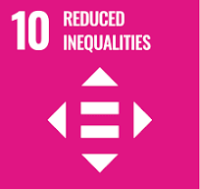

Review Mechanism
- Annual Ethics Performance Review
- An annual ethics performance review is conducted to assess progress towards ethical goals and compliance with the Ethics Policy.
- Key achievements, challenges, and areas for improvement are identified through a comprehensive evaluation process.

- Continuous Improvement
- Feedback from performance reviews, internal audits, and stakeholder engagement activities is used to identify opportunities for continuous improvement.
- Adjustments to ethical strategies, policies, and action plans are made as necessary to enhance compliance and address emerging issues.

- Policy Review and Update
- The Compliance Officer reviews this policy annually to ensure alignment with changing regulatory requirements, industry best practices, and stakeholder expectations.
- Company can also change or review policy if any necessary changes is required.
- Updates to the policy are communicated internally, and relevant training is provided to ensure awareness and compliance with ethical standards.

Version | Date | Description of Changes | Approved By
1.0 | 01-01-2024 | Initial release of the Ethics Policy | Management
2.0 | 01-01-2026 | Add new content regarding Information security and conflict of Interest | Management

(Signature)
Approved By:
Designations:
Last Review Date: 01-01-2026 Next Review Date: 01-01-2031

Employee Acknowledgement Form: Ethics Policy

I acknowledge that I have received, read, and understood Arminak Solutions LLC dba KBL Cosmetics Ethics Policy. I am aware of the company's commitment to upholding ethical standards, promoting a diverse and inclusive workplace, and ensuring the protection of human rights across all operations and supply chains.
I understand my role in supporting this policy, including complying with all applicable laws and regulations, respecting human rights, and fostering a safe and inclusive work environment. I agree to adhere to ethical practices in my daily work, report any ethical concerns, and contribute ideas for continuous improvement.
By signing below, I confirm my commitment to upholding Arminak Solutions LLC dba KBL Cosmetics Ethics Policy and supporting the company’s efforts in maintaining ethical practices.

Employee Name: ______________________

Date: _______________
Employee Signature: ____________________

